**Discrete Mathematics Exam1**

**Exercise1**: Let s be the following statement.

If it is raining, then the ground is wet.

1. Translate the above statement into symbols of formal logic.

P= it is raining

Q= the ground is wet

Original statement, the conditional, is p Implies Q

(b) Give the converse of s and translate into English.

Q implies P. If the ground is wet, it is raining

(c) Give the Contrapositive of s and translate into English.

Not Q implies Not P. if the ground is not wet, it is not raining

(d) Which of the statement (b) or (c)is (a) equivalent to?

Statement c because the contrapositive and the conditional have the same truth value

**Exercise 2**: Is the following statement a tautology, a contradiction or neither .

$$\left(˥p⋁q\right)→˥(˥q)⋀˥p$$

Tautology, because it is a true statement. Using double negation, we are already given that it is not p. not not Q means that it still implies q, and then we are also saying that it implies p.

**Exercise3**:Write a proof sequence for the following assertion. Justify each step.

$\left.\begin{aligned}p→˥q \\ r→(p⋀q)\end{aligned}\right\}⟹˥r$

**Exercise4**: 1)The domain of this problem is some unspecified collection of numbers. Consider the

predicate

$P\left(x,y\right)="x$ is greater than $y".$

a)Translate the following statement into predicate logic.

Every number has a number that is greater than it.

b)Negate your expression from part(a), and simplify it so that no quantifier or connective lies

within the scope of the negation.

c)Translate your expression from part b) into understandable English.

2)a)We assume that the equation with variable in it is a predicate in the domain of

real number.

Tell whether the following statement is true or false . If false find a counterexample .

$\left(∀y\right)(∃x)(x^{2}+y^{2}=1)$

b) Find the negation of the above statement.

**Exercise 5**:a) We assume that if $n^{2}$ is multiple 3 then $n$ is a multiple of 3.

(you can earn 3 extra points if you can prove it)

b) Using a) and a proof by contraction that $\sqrt{3}$ is an irrational number

c) Use b) to show that $\sqrt{3}+\sqrt{5}$ is an irrational number

**Exercise 6**: 1) Compute the minimal number of colors needed to color the following graph . Explain why

fewer color cannot be used.

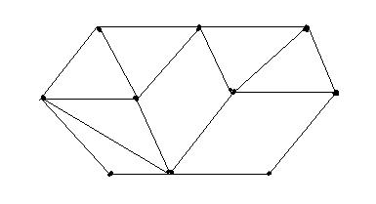

2)Consider the following list of numbers.

224, 784, 321, 511, 702, 66, 76,105,106

a) Place the numbers , in order given , into a binary search tree.

b) Find the height of the tree

c) how many comparison are needed to find the number 105.

d) Find the new tree by inserting the number 350 into your binary search tree.